**Install Hadoop: Setting up a Single Node Hadoop Cluster**

From our previous blogs on [***Hadoop Tutorial Series***](http://www.edureka.co/blog/hadoop-tutorial?utm_source=blog&utm_medium=related-posts&utm_campaign=install-hadoop), you must have got a theoretical idea about Hadoop, HDFS and its architecture. I hope you would have liked our previous blog on [***HDFS Architecture***](http://www.edureka.co/blog/apache-hadoop-hdfs-architecture?utm_source=blog&utm_medium=content-link&utm_campaign=install-hadoop), now I will take you through the practical knowledge about Hadoop and HDFS. The first step forward is to install Hadoop.

There are two ways to install Hadoop, i.e. **Single node** and **Multi node**.

**Single node cluster** means only one DataNode running and setting up all the NameNode, DataNode, ResourceManager and NodeManager on a single machine. This is used for studying and testing purposes. For example, let us consider a sample data set inside a healthcare industry. So, for testing whether the Oozie jobs have scheduled all the processes like collecting, aggregating, storing and processing the data in a proper sequence, we use single node cluster. It can easily and efficiently test the sequential workflow in a smaller environment as compared to large environments which contains terabytes of data distributed across hundreds of machines.

While in a **Multi node cluster**, there are more than one DataNode running and each DataNode is running on different machines. The multi node cluster is practically used in organizations for analyzing Big Data. Considering the above example, in real time when we deal with petabytes of data, it needs to be distributed across hundreds of machines to be processed. Thus, here we use multi node cluster.



In this blog, I will show you how to install Hadoop on a single node cluster.

**Prerequisites**

* *VIRTUAL BOX*: it is used for installing the operating system on it.
* *OPERATING SYSTEM*: You can install Hadoop on Linux based operating systems. Ubuntu and CentOS are very commonly used. In this tutorial, we are using CentOS.
* *JAVA*: You need to install the Java 8 package on your system.
* *HADOOP*: You require Hadoop 2.7.3 package.

**Install Hadoop**

**Step 1:** [Click here](https://goo.gl/ipdJJa) to download the Java 8 Package. Save this file in your home directory.

**Step 2:** Extract the Java Tar File.

***Command*:** tar -xvf jdk-8u101-linux-i586.tar.gz

Untar Java - Install Hadoop - Edureka

**Step 3:** Download the Hadoop 2.7.3 Package.

***Command*:** wget https://archive.apache.org/dist/hadoop/core/hadoop-2.7.3/hadoop-2.7.3.tar.gz

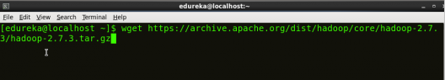

**Step 4:** Extract the Hadoop tar File.

***Command***: tar -xvf hadoop-2.7.3.tar.gz

Extract Hadoop Package - Install Hadoop - Edureka

**Step 5:** Add the Hadoop and Java paths in the bash file (.bashrc).

Open**.** **bashrc** file. Now, add Hadoop and Java Path as shown below.

***Command*:**  vi .bashrc

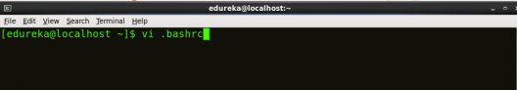

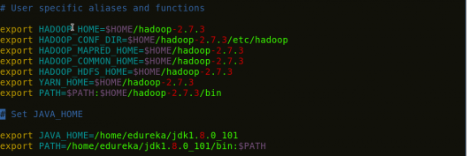

Then, save the bash file and close it.

For applying all these changes to the current Terminal, execute the source command.

***Command*:** source .bashrc

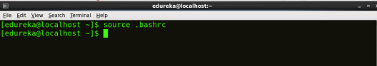

To make sure that Java and Hadoop have been properly installed on your system and can be accessed through the Terminal, execute the java -version and hadoop version commands.

***Command*:** java -version

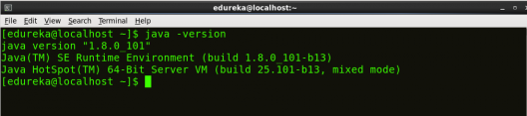

***Command*:** hadoop version

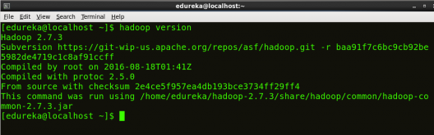

**Step 6:** Edit the [**Hadoop Configuration files**](http://www.edureka.co/blog/explaining-hadoop-configuration/?utm_source=blog&utm_medium=content-link&utm_campaign=install-hadoop).

***Command:*** cd hadoop-2.7.3/etc/hadoop/

***Command:*** ls

All the Hadoop configuration files are located in **hadoop-2.7.3/etc/hadoop** directory as you can see in the snapshot below:

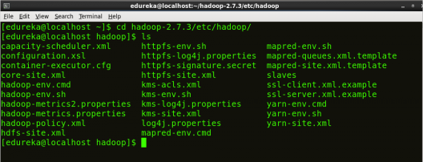

**Step 7:** Open *core-site.xml* and edit the property mentioned below inside configuration tag:

*core-site.xml* informs Hadoop daemon where NameNode runs in the cluster. It contains configuration settings of Hadoop core such as I/O settings that are common to HDFS & MapReduce.

***Command*:** vi core-site.xml

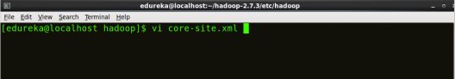



|  |  |
| --- | --- |
| 1  2  3  4  5  6  7  8 | <?xml version="1.0" encoding="UTF-8"?>  <?xml-stylesheet type="text/xsl" href="configuration.xsl"?>  <configuration>  <property>  <name>fs.default.name</name>  <value><hdfs://localhost:9000></value>  </property>  </configuration> |

**Step 8:** Edit *hdfs-site.xml*and edit the property mentioned below inside configuration tag:

*hdfs-site.xml* contains configuration settings of HDFS daemons (i.e. NameNode, DataNode, Secondary NameNode). It also includes the replication factor and block size of HDFS.

***Command*:** vi hdfs-site.xml

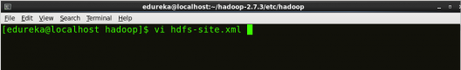

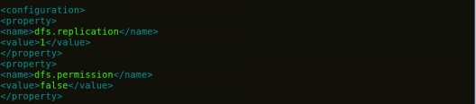

|  |  |
| --- | --- |
| 1  2  3  4  5  6  7  8  9  10  11  12 | <?xml version="1.0" encoding="UTF-8"?>  <?xml-stylesheet type="text/xsl" href="configuration.xsl"?>  <configuration>  <property>  <name>dfs.replication</name>  <value>1</value>  </property>  <property>  <name>dfs.permission</name>  <value>false</value>  </property>  </configuration> |

**Step 9:** Edit the *mapred-site.xml* file and edit the property mentioned below inside configuration tag:

*mapred-site.xml* contains configuration settings of MapReduce application like number of JVM that can run in parallel, the size of the mapper and the reducer process,  CPU cores available for a process, etc.

In some cases, mapred-site.xml file is not available. So, we have to create the mapred-site.xml file using mapred-site.xml template.

***Command*:** cp mapred-site.xml.template mapred-site.xml

***Command*:** vi mapred-site.xml.

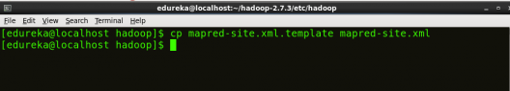

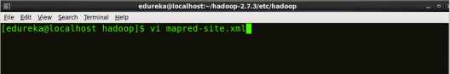



|  |  |
| --- | --- |
| 1  2  3  4  5  6  7  8 | <?xml version="1.0" encoding="UTF-8"?>  <?xml-stylesheet type="text/xsl" href="configuration.xsl"?>  <configuration>  <property>  <name>mapreduce.framework.name</name>  <value>yarn</value>  </property>  </configuration> |

**Step 10:** Edit *yarn-site.xml* and edit the property mentioned below inside configuration tag:

*yarn-site.xml* contains configuration settings of ResourceManager and NodeManager like application memory management size, the operation needed on program & algorithm, etc.

***Command*:** vi yarn-site.xml

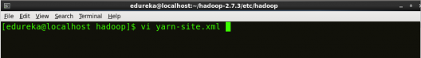

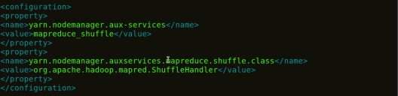

|  |  |
| --- | --- |
| 1  2  3  4  5  6  7  8  9  10  11 | <?xml version="1.0">  <configuration>  <property>  <name>yarn.nodemanager.aux-services</name>  <value>mapreduce_shuffle</value>  </property>  <property>  <name>yarn.nodemanager.auxservices.mapreduce.shuffle.class</name>  <value>org.apache.hadoop.mapred.ShuffleHandler</value>  </property>  </configuration> |

**Step 11:** Edit *hadoop-env.sh* and add the Java Path as mentioned below:

*hadoop-env.sh* contains the environment variables that are used in the script to run Hadoop like Java home path, etc.

***Command*:** vi hadoop–env.sh

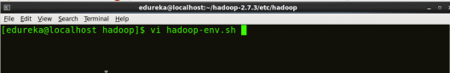

Property of hadoop-env - Install Hadoop - Edureka

**Step 12:** Go to Hadoop home directory and format the NameNode.

***Command*:** cd

***Command*:** cd hadoop-2.7.3

***Command*:** bin/hadoop namenode -format

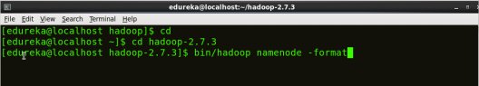

This formats the HDFS via NameNode. This command is only executed for the first time. Formatting the file system means initializing the directory specified by the dfs.name.dir variable.

Never format, up and running Hadoop filesystem. You will lose all your data stored in the HDFS.

**Step 13:** Once the NameNode is formatted, go to hadoop-2.7.3/sbin directory and start all the daemons.

***Command:***cd hadoop-2.7.3/sbin

Either you can start all daemons with a single command or do it individually.

***Command:****./*start-all.sh

The above command is a combination of***start-dfs.sh, start-yarn.sh*** & ***mr-jobhistory-daemon.sh***

Or you can run all the services individually as below:

**Start NameNode:**

The NameNode is the centerpiece of an HDFS file system. It keeps the directory tree of all files stored in the HDFS and tracks all the file stored across the cluster.

***Command:*** ./hadoop-daemon.sh start namenode

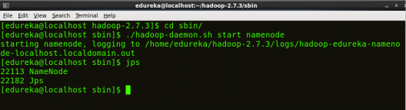

**Start DataNode:**

On startup, a DataNode connects to the Namenode and it responds to the requests from the Namenode for different operations.

***Command:*** ./hadoop-daemon.sh start datanode

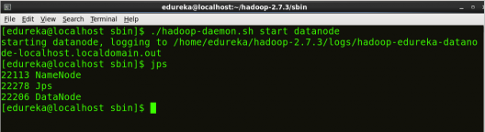

**Start ResourceManager:**

ResourceManager is the master that arbitrates all the available cluster resources and thus helps in managing the distributed applications running on the YARN system. Its work is to manage each NodeManagers and the each application’s ApplicationMaster.

***Command:*** ./yarn-daemon.sh start resourcemanager

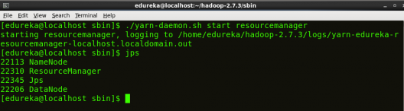

**Start NodeManager:**

The NodeManager in each machine framework is the agent which is responsible for managing containers, monitoring their resource usage and reporting the same to the ResourceManager.

***Command:*** ./yarn-daemon.sh start nodemanager

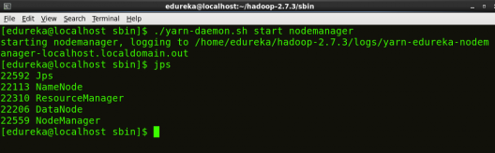

**Start JobHistoryServer:**

JobHistoryServer is responsible for servicing all job history related requests from client.

***Command*:** ./mr-jobhistory-daemon.sh start historyserver

**Step 14:** To check that all the Hadoop services are up and running, run the below command.

***Command:*** jps

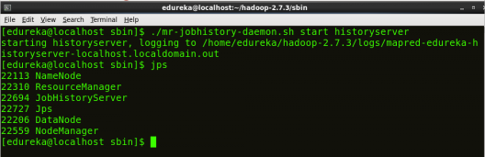

**Step 15:** Now open the Mozilla browser and go to **localhost**:**50070/dfshealth.html** to check the NameNode interface.

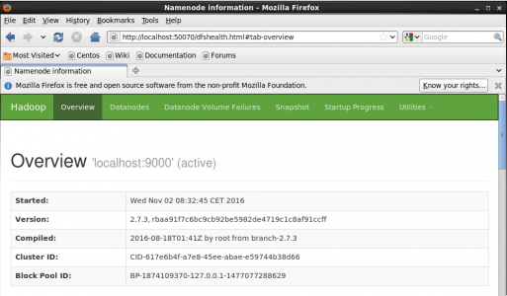

Congratulations, you have successfully installed a single node Hadoop cluster in one go. In our next blog of [***Hadoop Tutorial Series***](http://www.edureka.co/blog/hadoop-tutorial?utm_source=blog&utm_medium=related-posts&utm_campaign=install-hadoop), we will be covering how to install Hadoop on a multi node cluster as well.

[<< Previous Blog](http://www.edureka.co/blog/overview-of-hadoop-2-0-cluster-architecture-federation?utm_source=blog&utm_medium=blog-cta&utm_campaign=hadoop-installation-p)   [Next Blog >>](http://www.edureka.co/blog/setting-up-a-multi-node-cluster-in-hadoop-2.X?utm_source=blog&utm_medium=blog-cta&utm_campaign=hadoop-installation-n)